Data Science 4931

Guha Shion

06/03/2017

Changyan Liu

Mid - Term Project Report

    My midterm project topic is 2016 video game statistics. I have three main potential questions about this project. Firstly, who is playing games? Secondly, what is the annual income of mobile game industry?  Thirdly, how many girls play the game and how many boys play the games? (gender in gaming).  Base on these three potential questions, I did some research online.

Firstly, who is playing games? I used Google to search main gaming web page, Big fish Bolg, I found some data. For example, 155 million Americans play  games regularly, 4 out of 5 households own a video game console, the average age of gamers is 35, the average number of years gamers have been playing games is 13 and same amount of time most students spend from elementary school through high school graduation. From these data, we know a fact that almost all of the family has someone to play the game. What’s more, in my opinions, there will be more and more people will play games in the future and the average age of gamers will be less than 30 because many kids will join this data set.

 Secondly, what is the annual income of mobile game industry? I got data set from a video games data analysis website (Statista). According to my research, every years mobile revenue will go up. Many gaming industries will earn more money in the future.

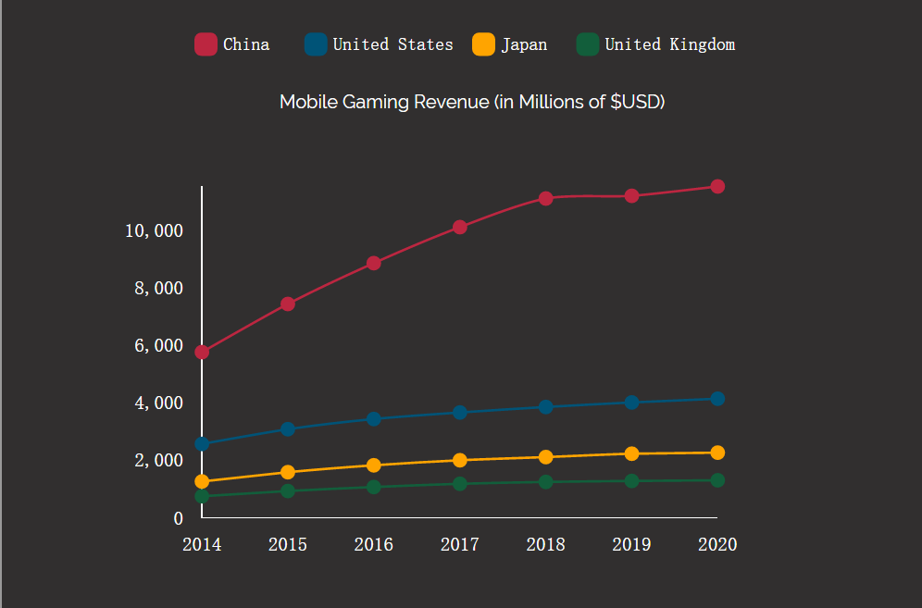

What’s more, when more people play games and many of the them wiling to pay money for play games. Comparing to last 20 years ago, when I was a kid, I didn’t know what the internet was, even for some adults who also didn’t familiar with internet. However, with the development of our society, many people now play video games when they were children. Therefore, they are willing to pay for some games because they played games when they were children.

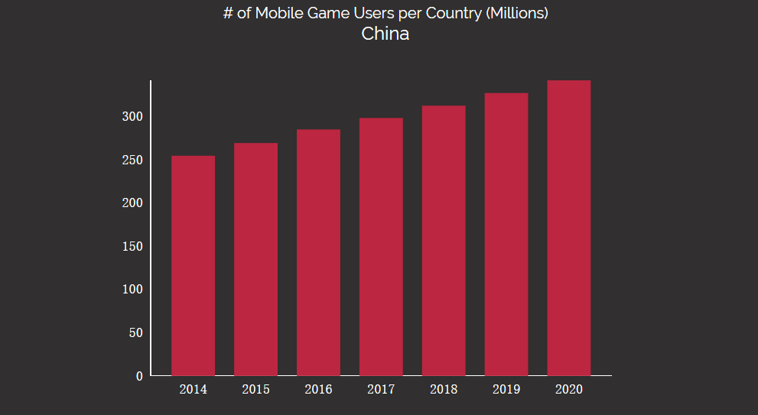

From this data set we know another fact that in the 2014, there were 240 million people who played mobile games. However, in 2020, according to the data set we know the mobile game user will be almost 320 million. We can use a simple math method to calculate the change. For example, 320 - 240 = 80. It is means that every year will increase 10 millions of users and growth rate is 240 / 320 = 0.75 = 75% ! This is a huge growth rate.

  Thirdly, for my last potential question, how many girls play the game and how many boys play the games? (gender in gaming). From my research from big fish bolg, I found 48% of females play games, 50% of males play games, 75% of the games industry is male, and the most frequent game purchasers 41% are female and 56% are male.

 In conclusion, from my research, many people will play video games in the future and they may want to pay for games. What’s more, more and more young people will often play games in the future. the average age of gamers should below 30.

Work Cited

Andrea Romero. 2016. Topic: Mobile gaming. (July 2016). Retrieved March 9, 2017 from https://www.statista.com/topics/1906/mobile-gaming/

krista Lofgren. 2016. 2016 Video Game Statistics & Trends | Big Fish Blog. (February 2016). Retrieved March 9, 2017 https://www.statista.com/topics/1906/mobile-gaming/